LAB 6

1. Selection Sort

PROGRAM:

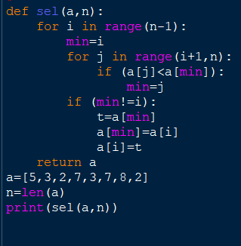

OUTPUT:

1. Bubble Sort

PROGRAM:

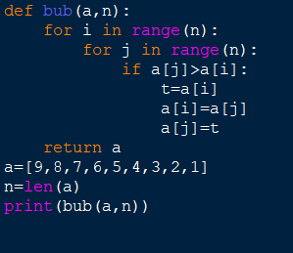

OUTPUT:

1. Insertion sort

PROGRAM:

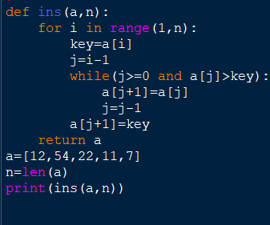

OUTPUT:

1. Sequential Search

PROGRAM:

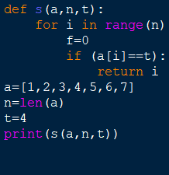

OUTPUT:

1. Brute-Force String Matching

PROGRAM:

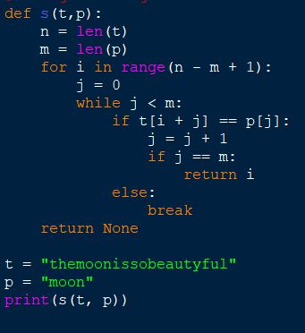

OUTPUT:

1. Closest-Pair

PROGRAM:

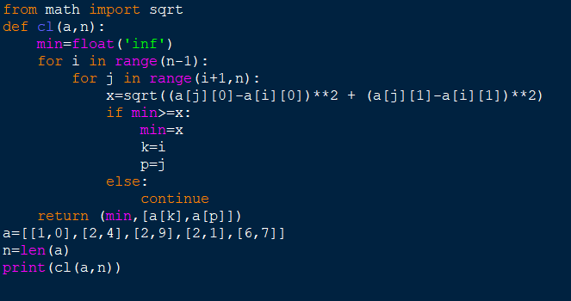

OUTPUT:

1. Convex-Hull Problems

PROGRAM:

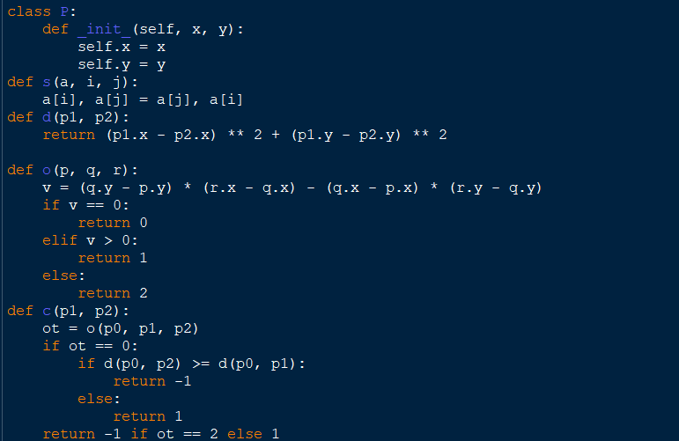

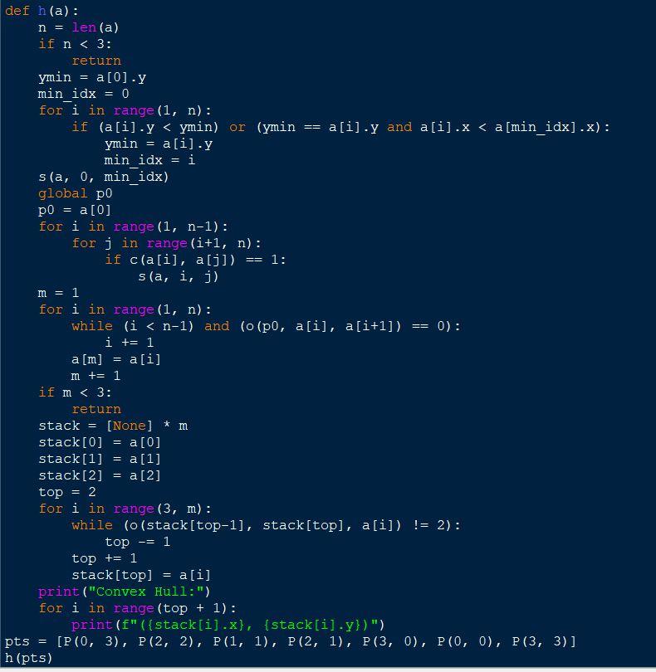

OUTPUT: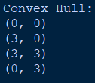

1. Exhaustive Search

PROGRAM:

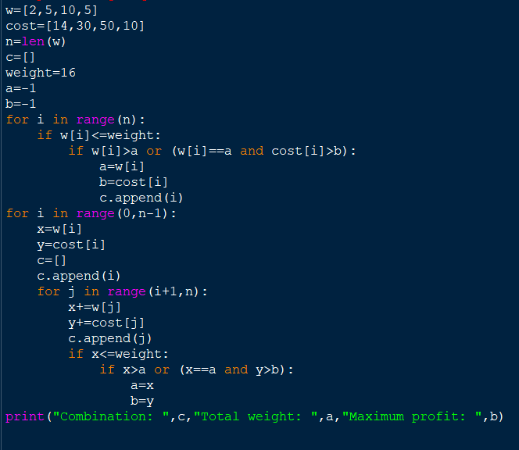

OUTPUT: